**RAINFALL PREDICTION USING MACHINE LEARNING**

**Source Code Screenshots:**

* We have worked on Project Titled as “Rainfall Prediction using Machine Learning Techniques”.
* Here, I am attaching the screenshots of the results which is coded in python language from the dataset of weatherAUS.csv.
* Firstly, importing pandas library and reading the dataset by using head() function.

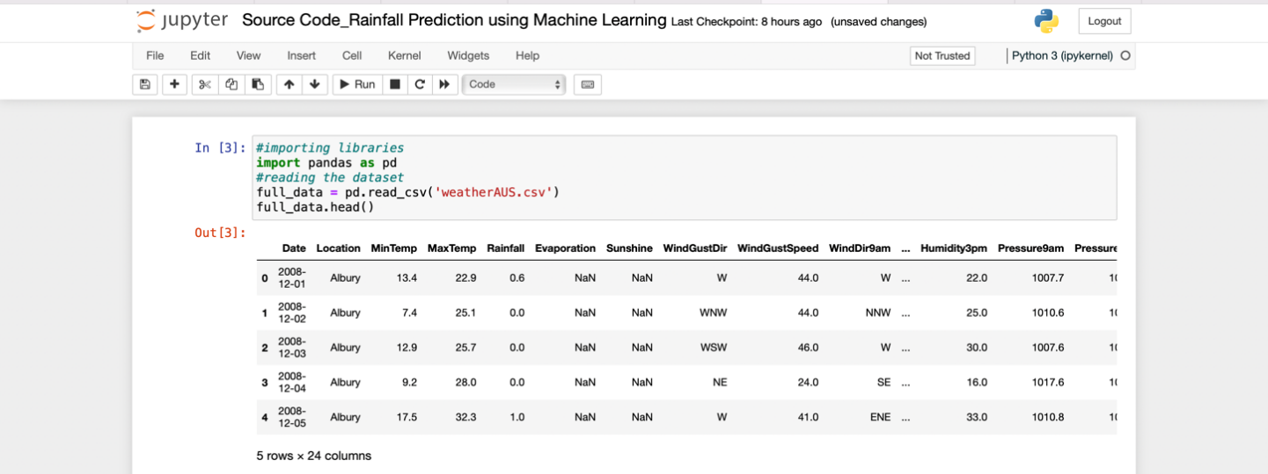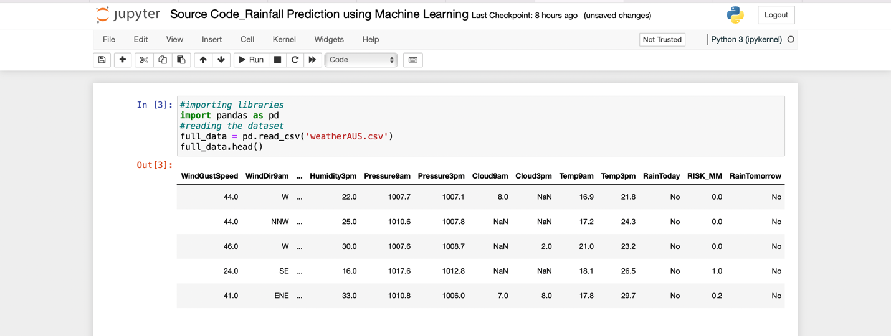

* Now, we are obtaining the date month & year from the dataset about the sunshine, wind, cloud, temperature, rain from the location and reading the dataframe.

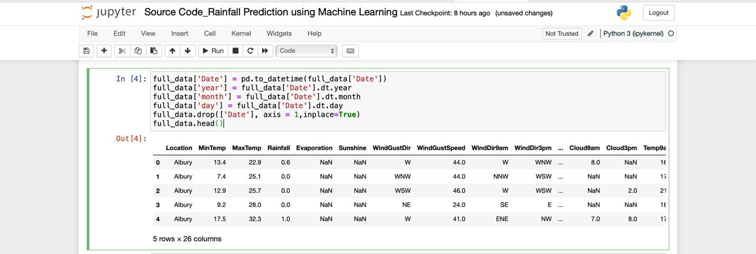

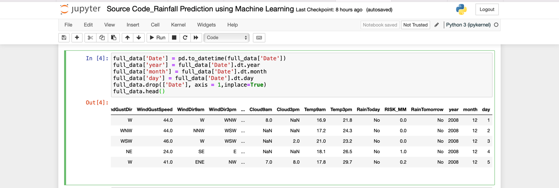

* By using the shape() function, obtained the dimensions of the dataframe.
* By using the info() function, obtained the summary of the dataframe about the datatype, memory usage, nonnull, coloumn, total number of datatypes such as float which are 17, integer are 3 and objects are 6.

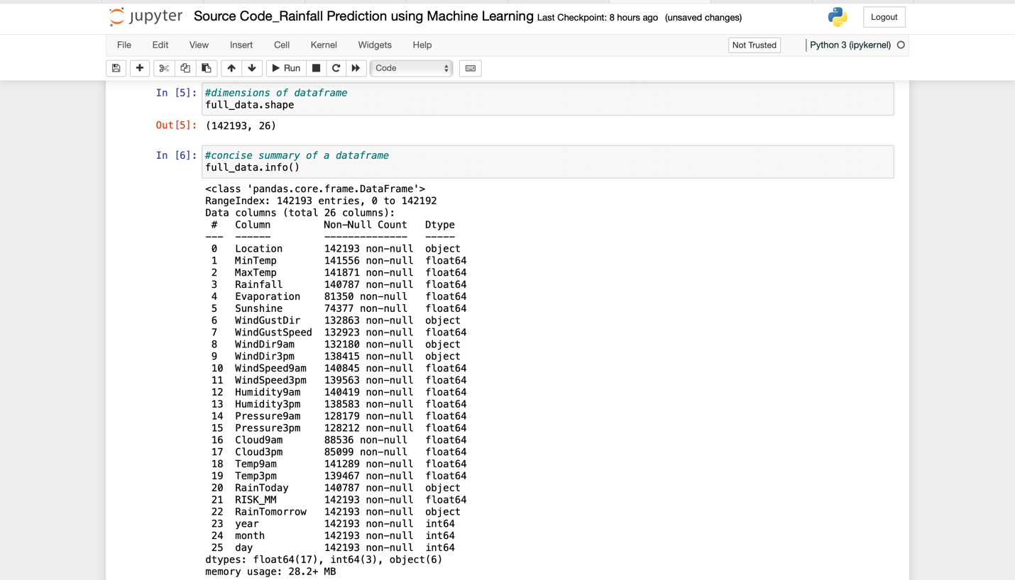

* Now, we are obtaining the result of the replaced dataframe from replace() function for having the chances of rainfall for today and tomorrow.

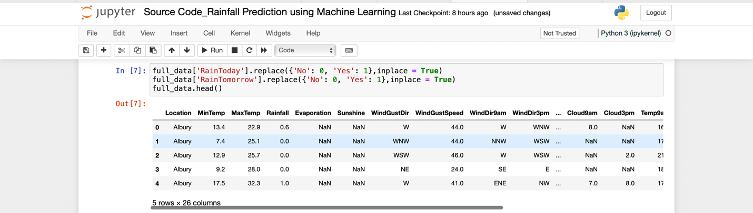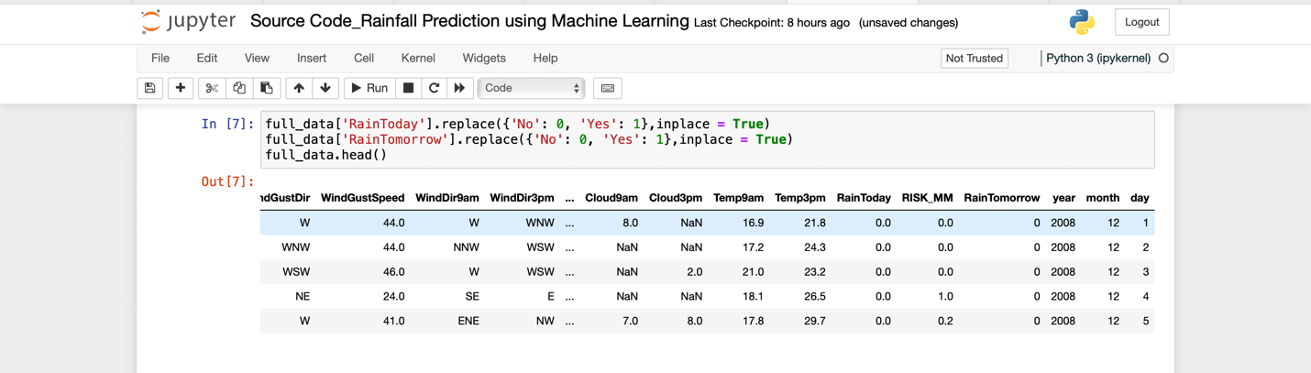

* Now, to visualise the data in bar chart for indication of rainfall in imbalanced dataset I have imported matplot.pyplot().
* By show() function we are able to view the chances of rainfall which is 78% Yes and 22% No simultaneously.

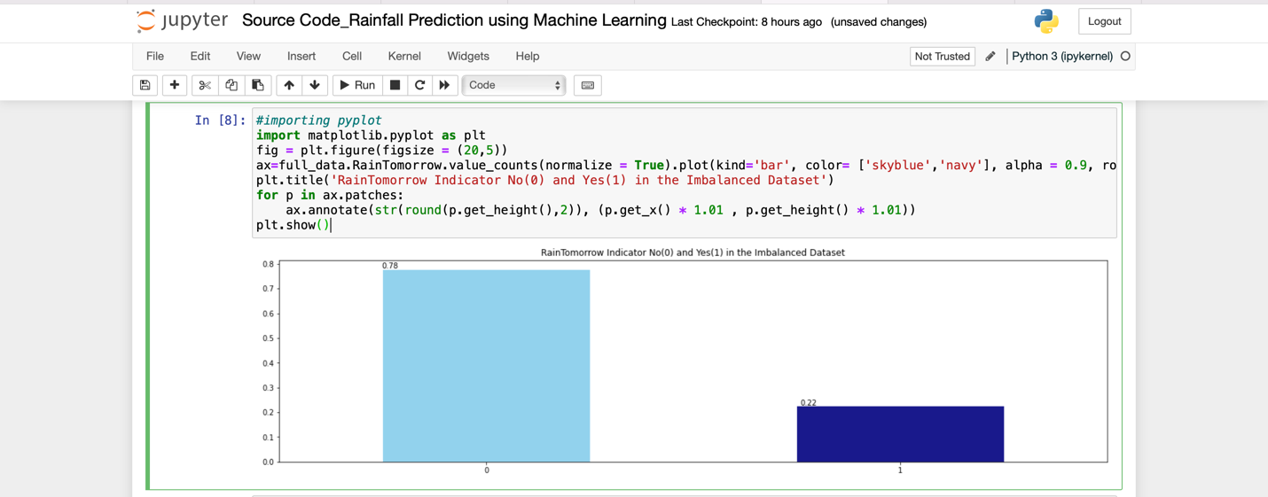

* Now, I am resampling the data to get the balanced dataset as I have obtained 1:1 chances of rainfall.

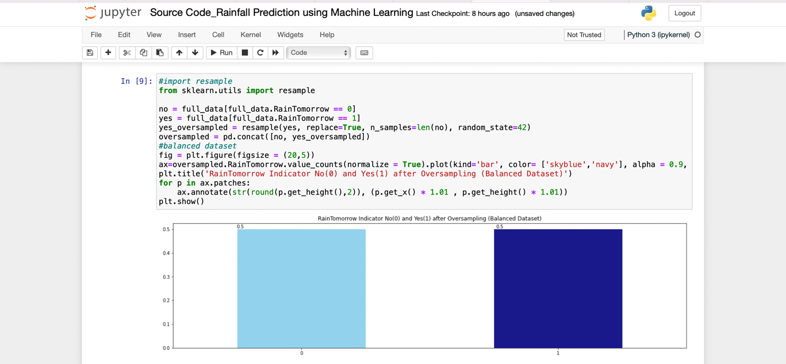

* Importing the seaborn to get the missing data pattern in training data which is obtained as below.

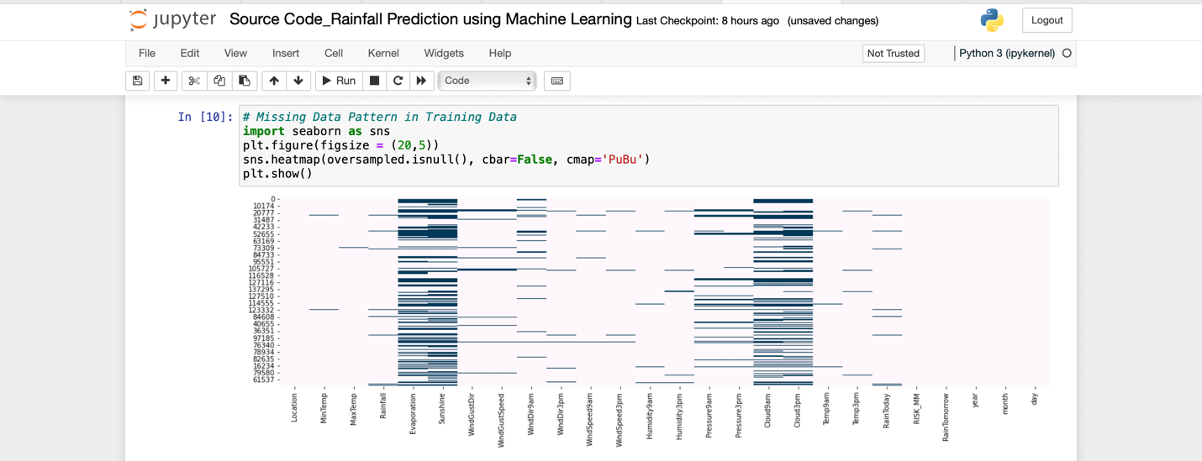

* Here I have obtained the total and percentage of change in temperature from sum() and count() function and concatenating it.

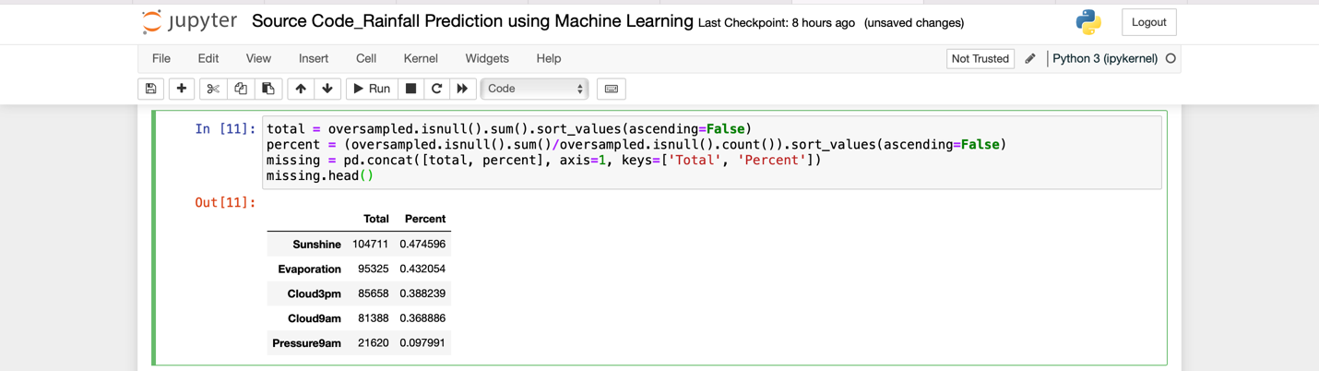

* Obtaining the datatype of coloumn.

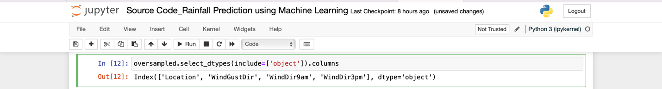

* Now, Imputing categorical variable with mode such as Location, WindGustDir, WindDir9am and WindDir3am by mode() function.
* Now, converting the categorical features to continuos features with label encoding by importing labelencoder & fittransform() function.
* Now, performing multiple imputation by chained equations by importing enable_iterative_imputer & IterativeImputer.
* Now, detecting & printing outliers with IQR .

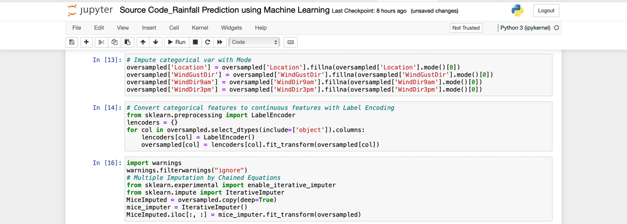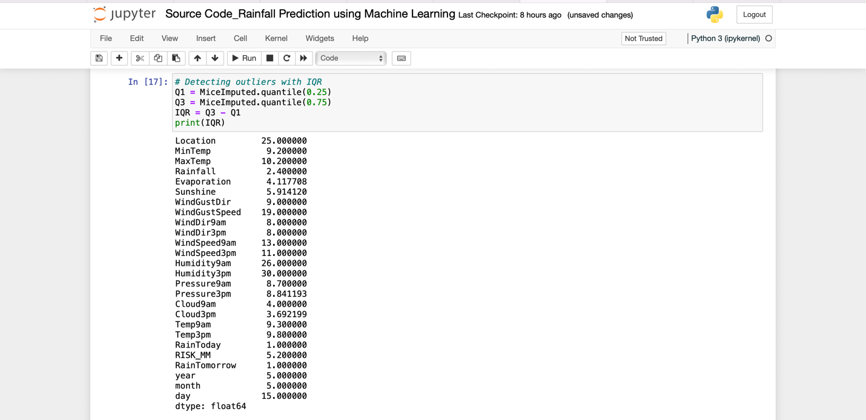

* Now, Removing outliers from the dataset and printing the shape() of the dataframe.

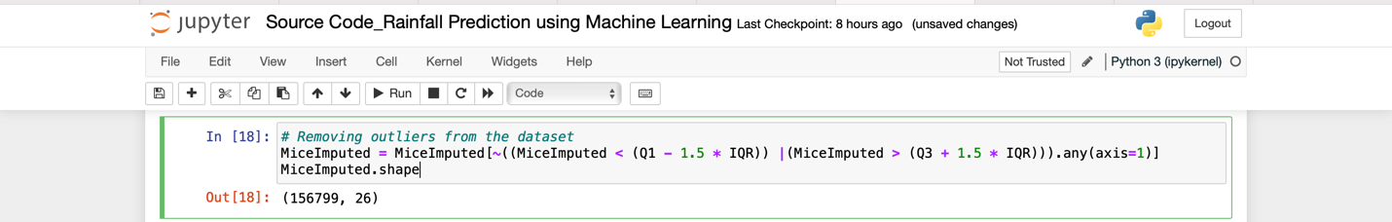

* Obtaining the correlation of the heatmap by using corr() function and visualizing the plot.

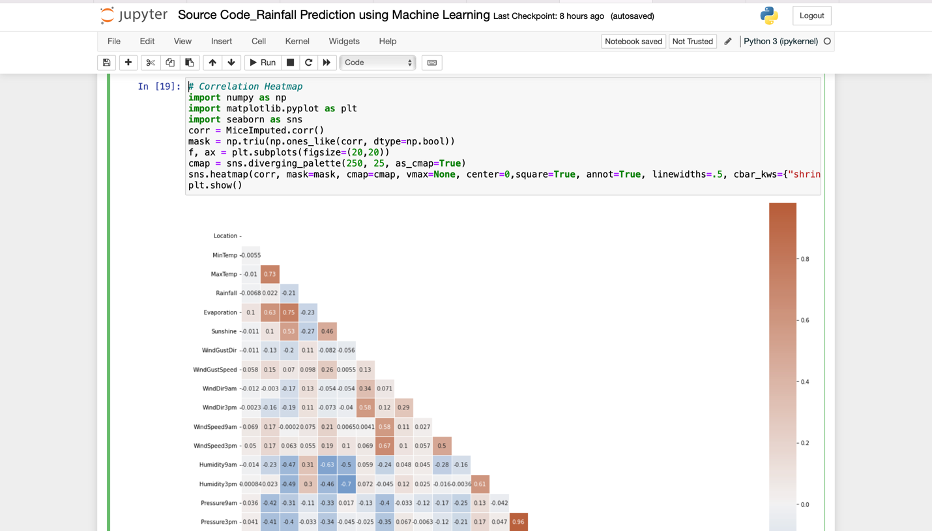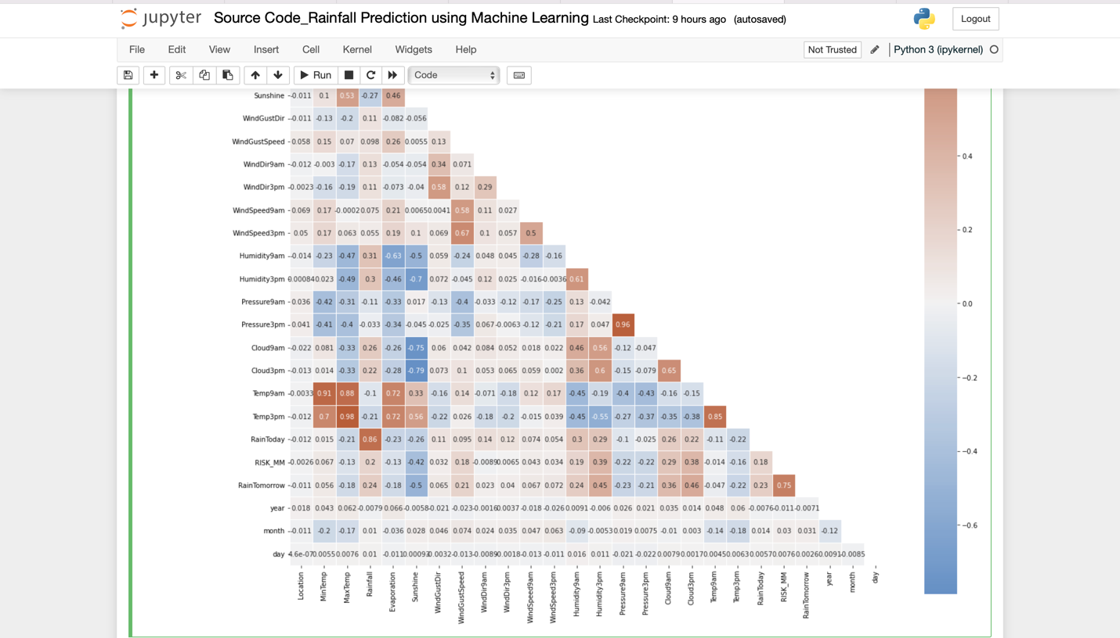

* Standardizing the data by using scaler() function.
* Featuring the data by Filter method with k=10 & printing all the coloumns.
* Obtaining the estimations of all the coloumns.
* Splitting the dataset into dataset and the training and testing set and normalizing the features using normalise() function.
* Now, importing the time, accuracy_scor, roc_curve etc., to obtain the values of the dataset.
* To obtain logistic regression of the dataset imported the logistic regression.
* Now, printing the ROC curve, weighted avg, macro avg, ROC area under curve, cohen’s kappa.

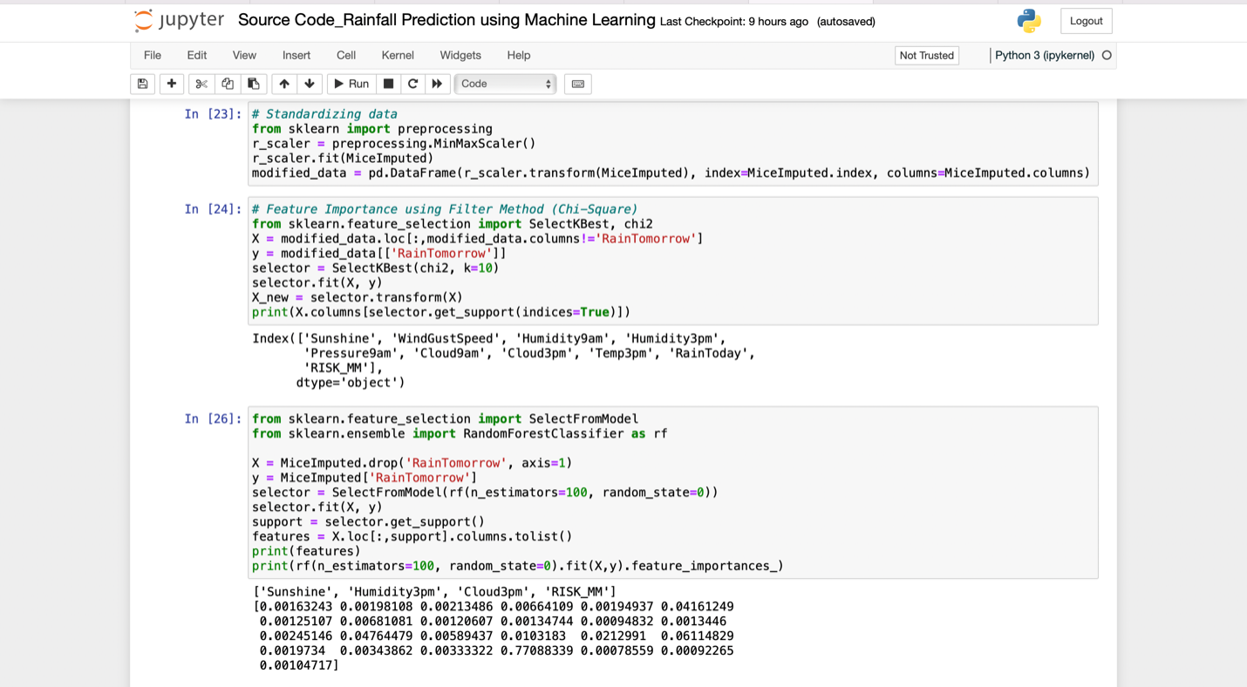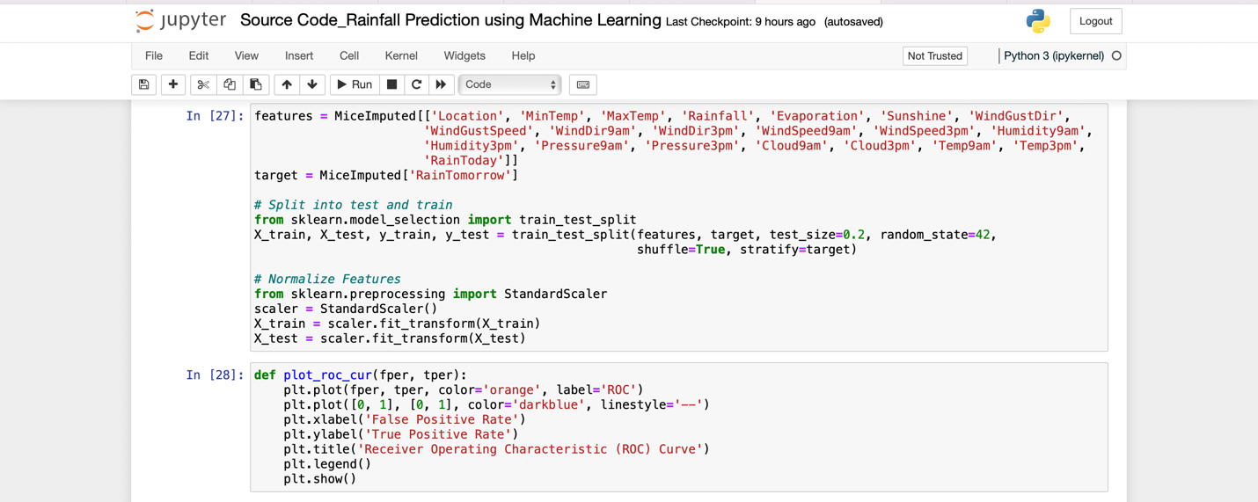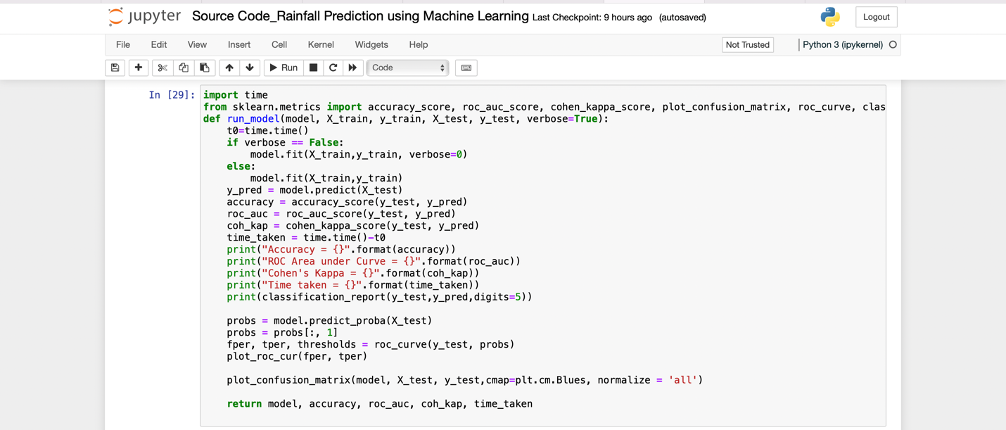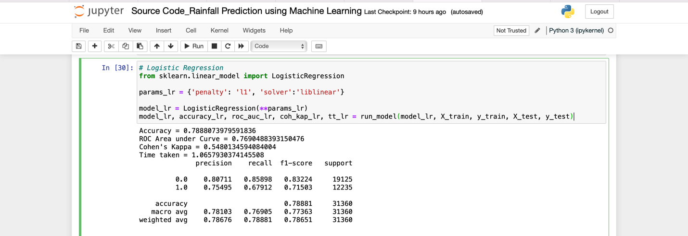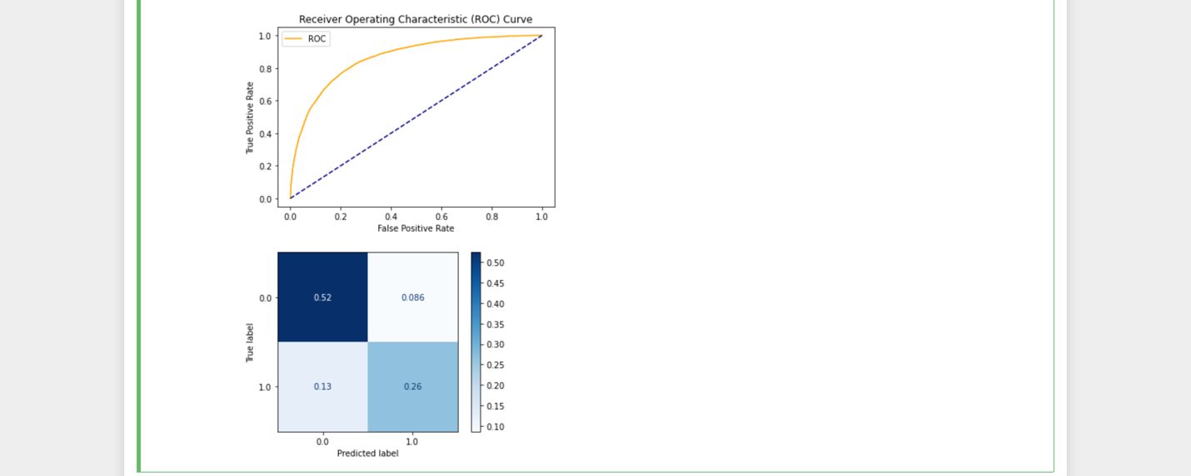

* Now, performing the decision tree for the above data by importing the DecisionTreeClassifier.
* Obtaining the Accuracy, ROC area under curve, macro avg, weighted avg, Cohen’s kappa respectively for decision tree.

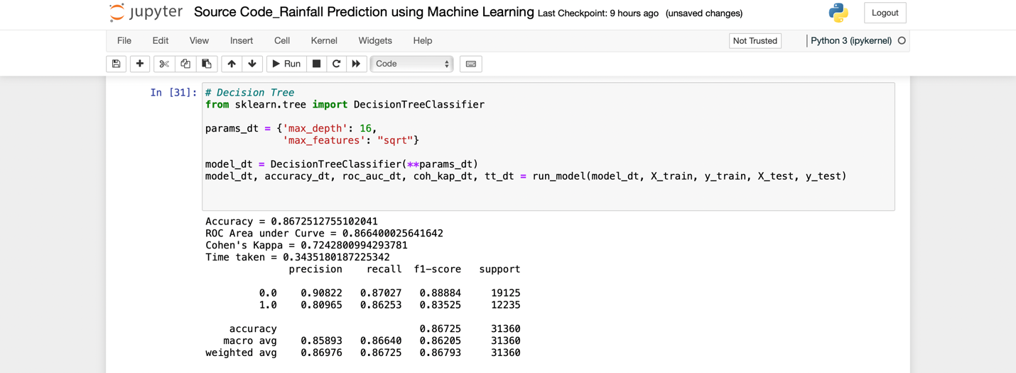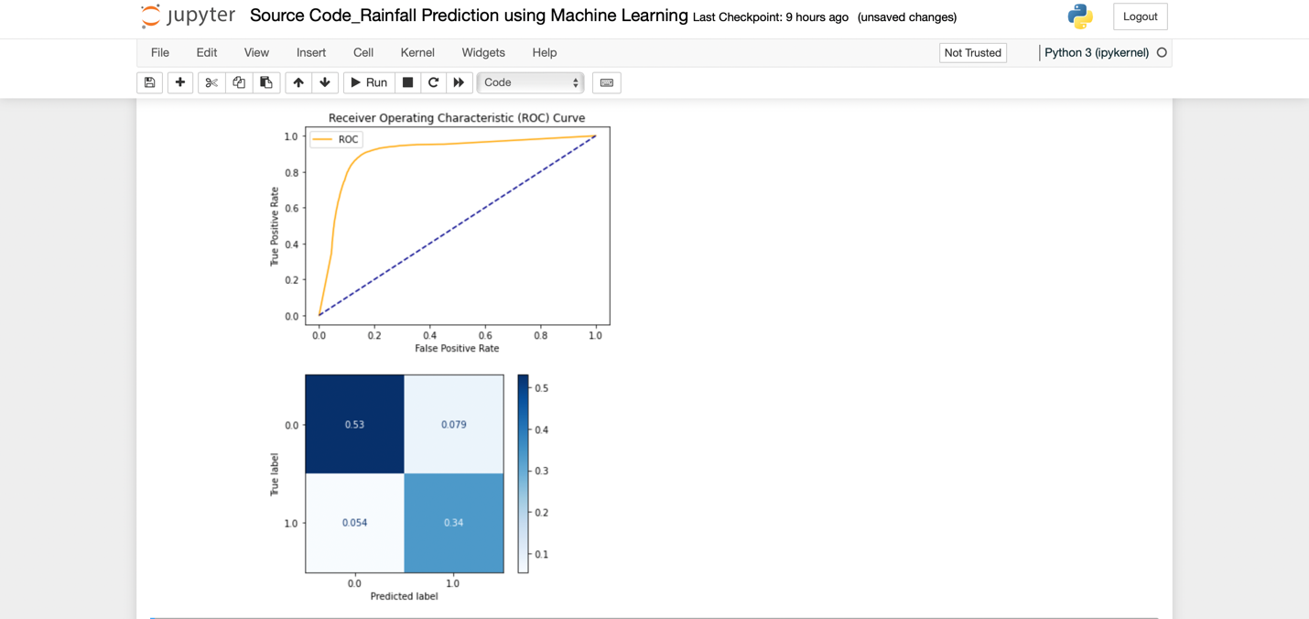

* Now, Performing the Neural Network for the above data by importing the MLPCClassifier.
* Obtaining the Accuracy, ROC area under curve, macro avg, weighted avg, Cohen’s kappa respectively for Neural Network.

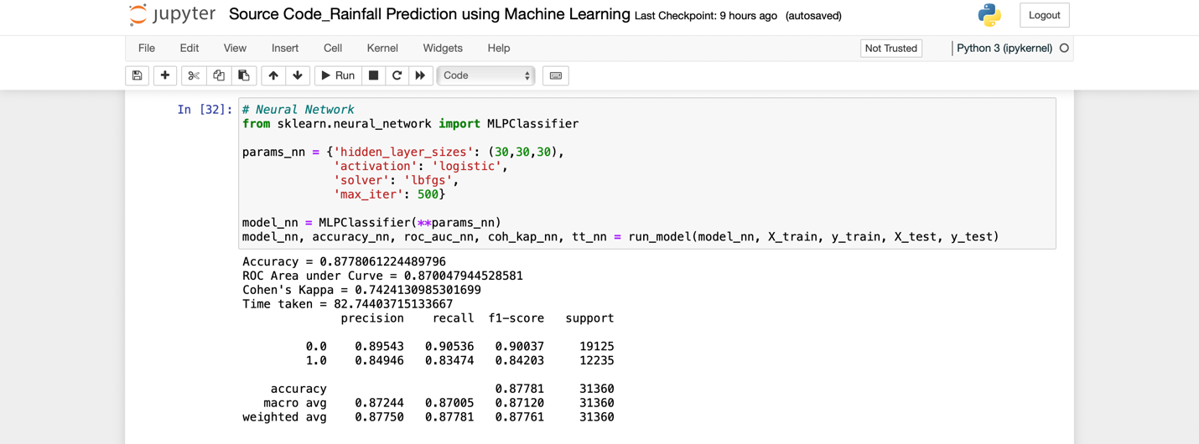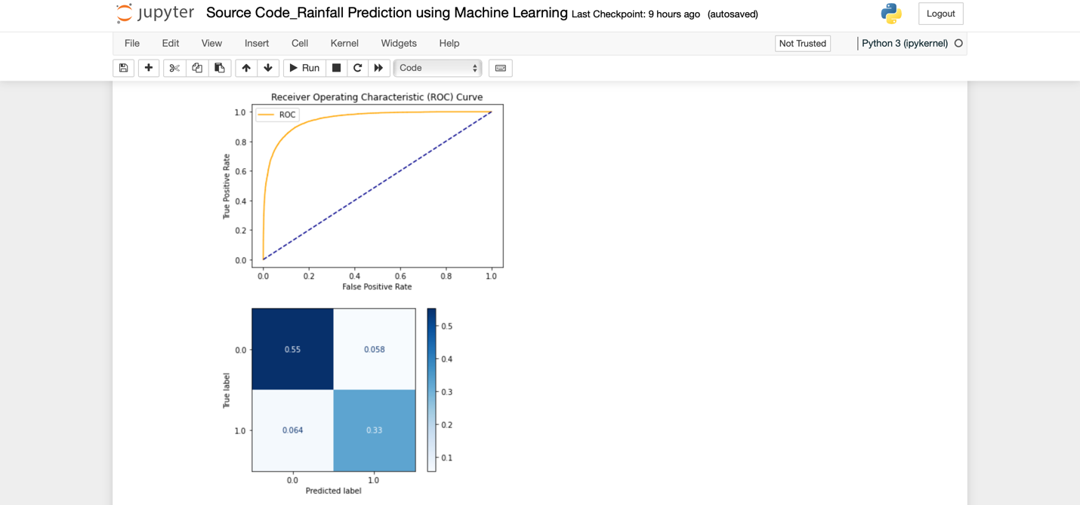

* Now, Performing the Random Forest for the above data by importing the RandomForestClassifier.
* Obtaining the Accuracy, ROC area under curve, macro avg, weighted avg, Cohen’s kappa respectively for Random Forest.

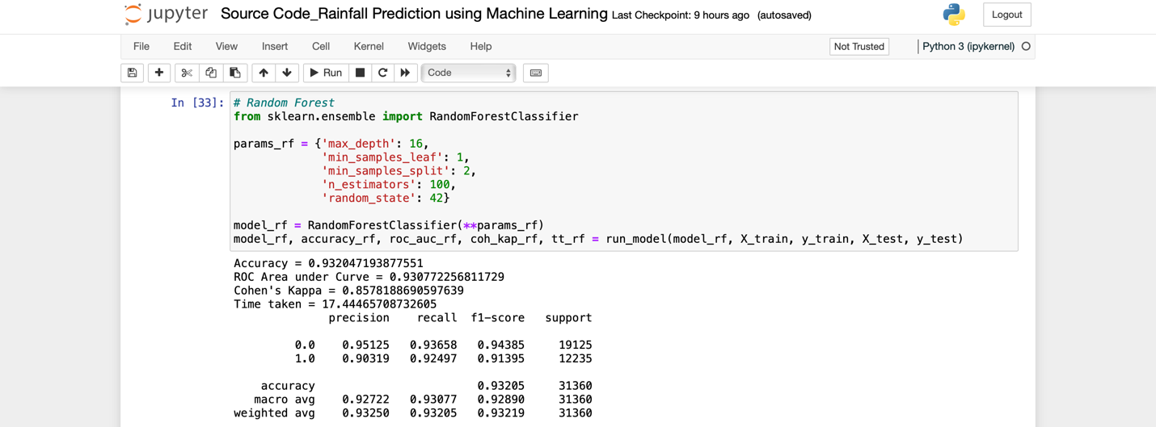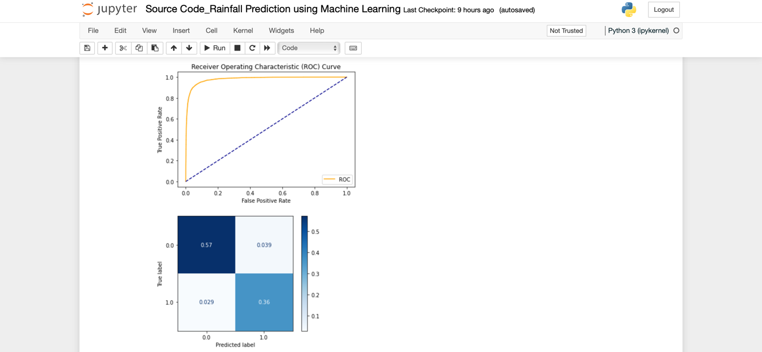

* Now, Performing the Light GBM for the above data by importing the lightgbm.
* Obtaining the Accuracy, ROC area under curve, macro avg, weighted avg, Cohen’s kappa respectively for Light GBM.

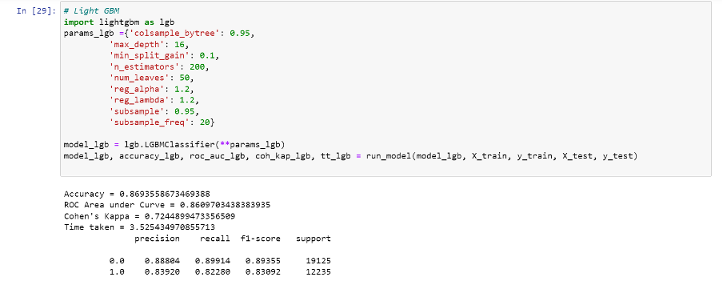

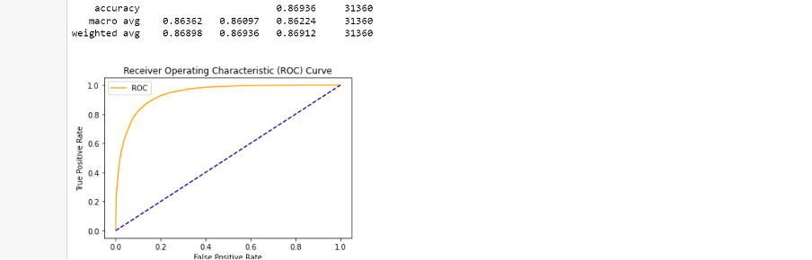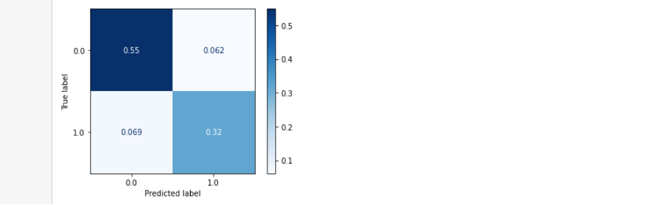

* By using pip install command install catboost.
* Now, Performing the Catboost for the above data by importing the catboost.
* Obtaining the Accuracy, ROC area under curve, macro avg, weighted avg, Cohen’s kappa respectively for Catboost.

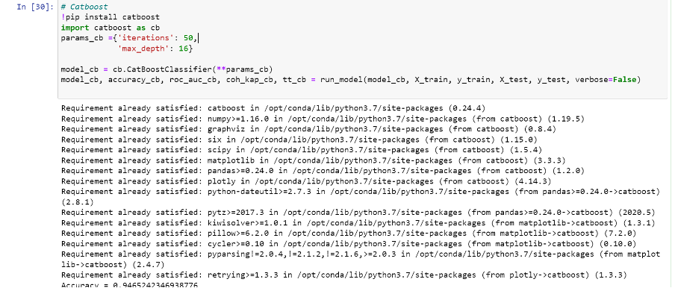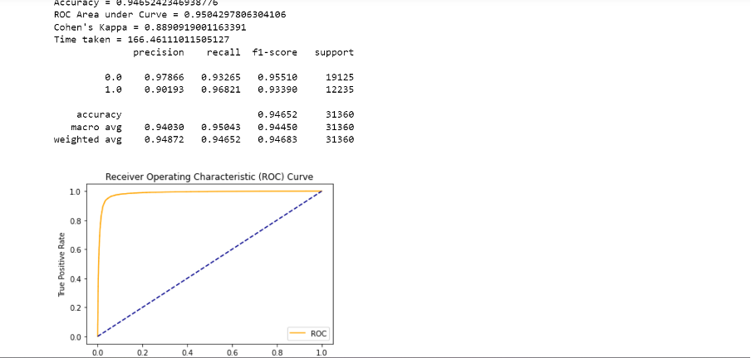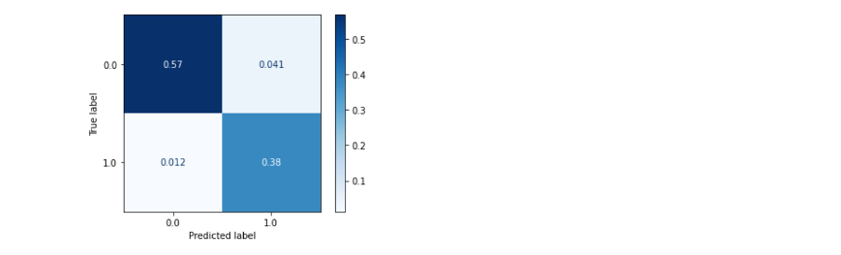

* Now, Performing the XGBoost for the above data by importing the xgboost.
* Obtaining the Accuracy, ROC area under curve, macro avg, weighted avg, Cohen’s kappa respectively for XGBoost.

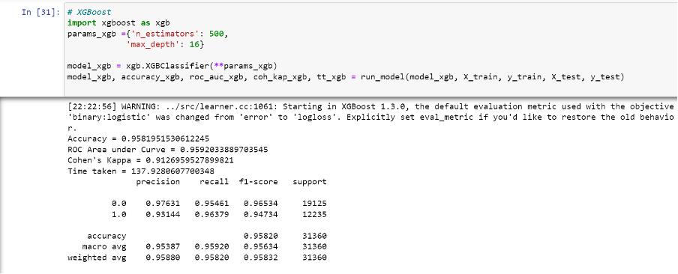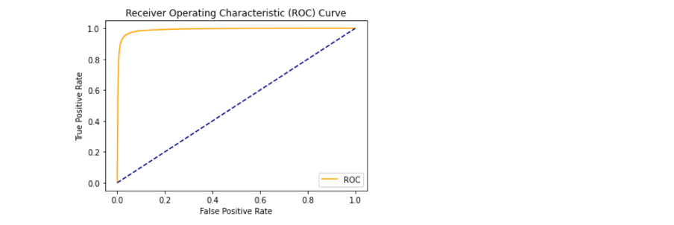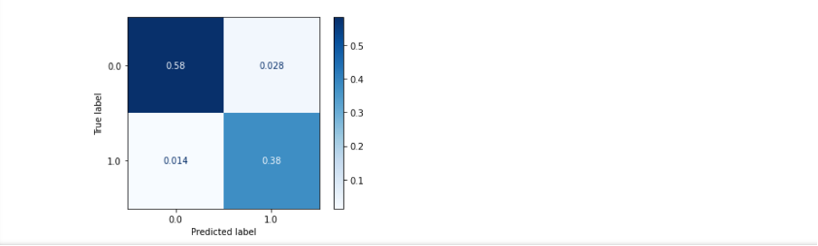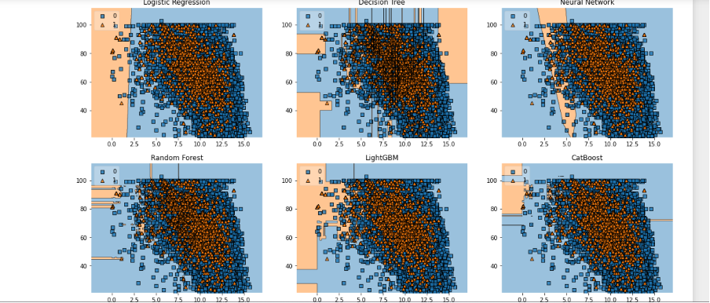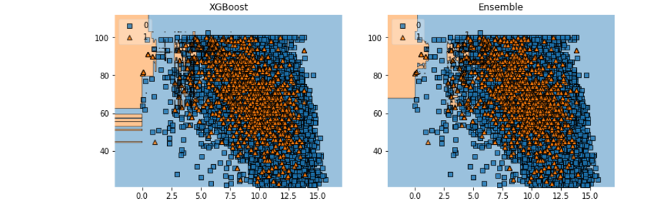

* Here, we are gathering the accuracy scores, ROC area under curve scores, Cohen’s kappa score of dataframe for all the above operations in which are performed in different operations.
* Time taken to perform the operations in all criterian.
* Model data for all the criterian.
* Visualising the data in line and bargraph which is named as Model Comparison: Accuracy and Timetaken for execution and for Area under ROC and Cohen’s Kappa.

